December Fitness Challenge
On the first day of fitness complete the exercise of the day, and color the box below. On the second day of fitness complete the exercise for day 2 and day 1, and color the boxes. Continue this for all 12 days, coloring in the boxes below as you go.
If you complete ALL of the 12 Days of Fitness Challenge, have your parents sign the bottom of the sheet and return completed sheet to Miss. Eisinger for a special prize!
1c
2c
1c
3=
1c
3c
2c
1c
4
3
4
5
2
1c
4
5
6
3
2
1
5
6
7
4
3
2
1c
6
7
8
5
4c
3
2c
1c
5
6
7
4
3
2
1c
8
9
2c
5
6
7
4
3
2
1c
8
9
10
5
6
7
4
3
2
1c
8
9
10
11
5
6
7
4
3
2
1c
8
9
10
11
12
Day 1
Day 2
Day 3
Day 4
Day 5
Day 6
Day 7
Day 8
Day 9
Day 10
Day 11
Day 12
Student Name: ____________________________ Student’s Teacher: _____________________
Parent Signature: __________________________

December Fitness Challenge
Below are the exercises for each of the days of the challenge. Always do the day and all of the one before it!
Remember on day 12 you do all of them!
Day 1  One Minute Plank Hold  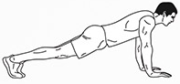 | Day 2  2 sets (30 sec) High Knees  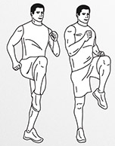 | Day 3  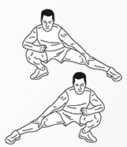3 Side Lunges (each side)
Day 4  4 Push Ups  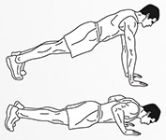 | Day 5  5 Burpees  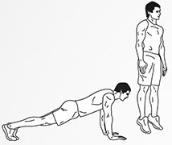 | Day 6  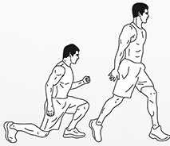6 Lunge Jumps
Day 7  7 Leg Lifts  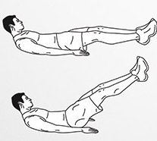 | Day 8  8 Mountain Climbers  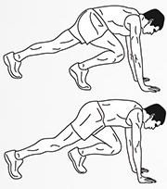 | Day 9  9 Jumping Jacks  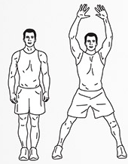
Day 10  10 Sitting Twists  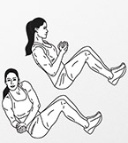 | Day 11  11 Squat Jumps  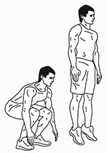 | Day 12  12 Windshield Wipers  